**Brownsville I.S.D.**





**READING WITH PURPOSE (CPQ) & THINK TURN TALK**

**SUBJECT: Reading-1st Grade- RESOURCE: HMH –Dr. Seuss**

**Genre: Biography**

**What text and graphic features did the author use? What is the purpose of these features?**

C:\Documents and Settings\ddycha\Local Settings\Temporary Internet Files\Content.IE5\D3TFXU7L\MCj03841720000[1].wmf

Making ConnectionsC:\Documents and Settings\ddycha\Local Settings\Temporary Internet Files\Content.IE5\1TTJYVJL\MCj03299300000[1].wmf

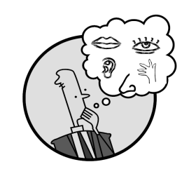Creating Mental Images

**Write your CPQ (comprehension purpose question) here.**

What do you think this story will be about? P.123

Making Inferences & PredictionsC:\Documents and Settings\ddycha\Local Settings\Temporary Internet Files\Content.IE5\PICBQBTG\MCj02503920000[1].wmf

Vocabulary word:

hit

**Think Turn Talk Question & page #**

Asking & Answering QuestionsC:\Documents and Settings\ddycha\Local Settings\Temporary Internet Files\Content.IE5\D3TFXU7L\MCj03841720000[1].wmf

How do the pictures show that Ted is funny? P.125

Determining Importance & Summarizing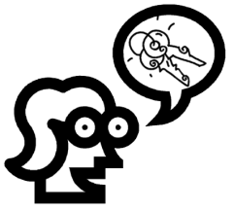

Vocabulary word:

sculpture

**Think Turn Talk Question & page #**

Why are Dr. Seuss’s books still popular today? P.136

Monitoring & ClarifyingC:\Documents and Settings\ddycha\Local Settings\Temporary Internet Files\Content.IE5\PICBQBTG\MCj04242520000[1].wmf

**Think Turn Talk Question & page #**