**Brownsville I.S.D.**



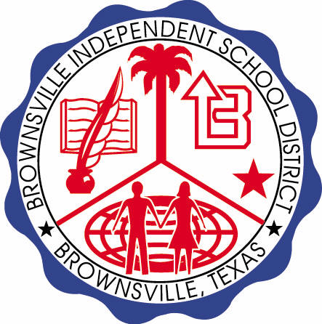

**READING WITH PURPOSE (CPQ) & THINK TURN TALK**

**SUBJECT: Reading-1st Grade- RESOURCE: HMH –A Musical Day**

**Genre: Realistic Fiction**

**What is the order of events of the selection? Why is it important?**

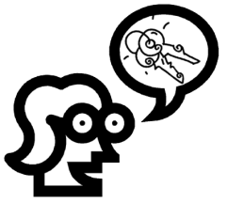

Making ConnectionsC:\Documents and Settings\ddycha\Local Settings\Temporary Internet Files\Content.IE5\1TTJYVJL\MCj03299300000[1].wmf

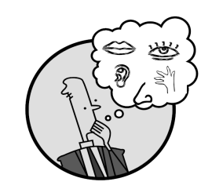Creating Mental Images

**Write your CPQ (comprehension purpose question) here.**

How do the children feel about Aunt Viv? What does this tell you about Aunt Viv? P.89

Making Inferences & PredictionsC:\Documents and Settings\ddycha\Local Settings\Temporary Internet Files\Content.IE5\PICBQBTG\MCj02503920000[1].wmf

Vocabulary word:

pluck

**Think Turn Talk Question & page #**

Asking & Answering QuestionsC:\Documents and Settings\ddycha\Local Settings\Temporary Internet Files\Content.IE5\D3TFXU7L\MCj03841720000[1].wmf

Why do you think it can be more fun to play music than to just listen to it? P.99

Determining Importance & Summarizing

Vocabulary word:

tap

**Think Turn Talk Question & page #**

How believable are the events in this story? Elaborate. P.100

Monitoring & ClarifyingC:\Documents and Settings\ddycha\Local Settings\Temporary Internet Files\Content.IE5\PICBQBTG\MCj04242520000[1].wmf

**Think Turn Talk Question & page #**