**Brownsville I.S.D.**





**READING WITH PURPOSE (CPQ) & THINK TURN TALK**

**SUBJECT: Reading-1st Grade- RESOURCE : HMH–How Animals Communicate**

**Genre: Informational Text**

**What facts would you select to support that animals can communicate?**

C:\Documents and Settings\ddycha\Local Settings\Temporary Internet Files\Content.IE5\PICBQBTG\MCj02503920000[1].wmf

Making ConnectionsC:\Documents and Settings\ddycha\Local Settings\Temporary Internet Files\Content.IE5\1TTJYVJL\MCj03299300000[1].wmf

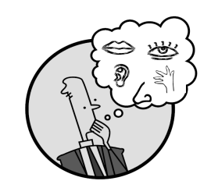Creating Mental Images

**Write your CPQ (comprehension purpose question) here.**

What can you tell about how animals communicate? P.53

Making Inferences & PredictionsC:\Documents and Settings\ddycha\Local Settings\Temporary Internet Files\Content.IE5\PICBQBTG\MCj02503920000[1].wmf

Vocabulary word:

grab

**Think Turn Talk Question & page #**

Asking & Answering QuestionsC:\Documents and Settings\ddycha\Local Settings\Temporary Internet Files\Content.IE5\D3TFXU7L\MCj03841720000[1].wmf

What would happen if an animal could not hear? P.57

Determining Importance & Summarizing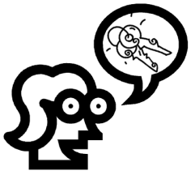

Vocabulary word:

pack

**Think Turn Talk Question & page #**

How do the animals on pages 58-59 use sight to communicate? P.59

Monitoring & ClarifyingC:\Documents and Settings\ddycha\Local Settings\Temporary Internet Files\Content.IE5\PICBQBTG\MCj04242520000[1].wmf

**Think Turn Talk Question & page #**