**Brownsville I.S.D.**



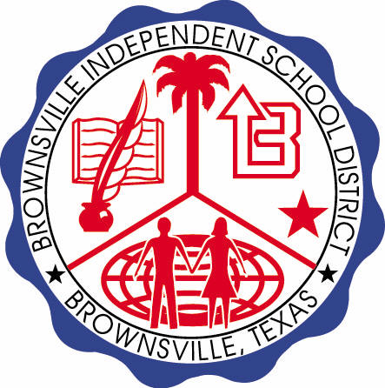

**READING WITH PURPOSE (CPQ) & THINK TURN TALK**

**SUBJECT: Reading-1st Grade RESOURCE : HMH –Jack and the Wolf**

**Genre: Fable**

**How does the main characters’ thinking change from the beginning to the end of the story?**

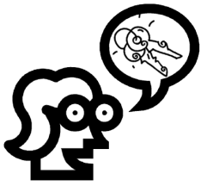

Making ConnectionsC:\Documents and Settings\ddycha\Local Settings\Temporary Internet Files\Content.IE5\1TTJYVJL\MCj03299300000[1].wmf

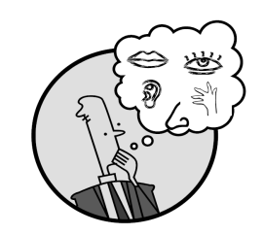Creating Mental Images

**Write your CPQ (comprehension purpose question) here.**

What does Jack decide to do for fun? Why do you think he yells “Wolf”? P.18

Making Inferences & PredictingC:\Documents and Settings\ddycha\Local Settings\Temporary Internet Files\Content.IE5\PICBQBTG\MCj02503920000[1].wmf

Vocabulary word:

trick

**Think Turn Talk Question & page #**

Asking & Answering QuestionsC:\Documents and Settings\ddycha\Local Settings\Temporary Internet Files\Content.IE5\D3TFXU7L\MCj03841720000[1].wmf

Why do Jack’s friends run up the hill when he yells “Wolf?” P.22

Determining Importance & Summarizing

Vocabulary word:

hill

**Think Turn Talk Question & page #**

What does Jack’s behavior say about him? P.24

Monitoring & ClarifyingC:\Documents and Settings\ddycha\Local Settings\Temporary Internet Files\Content.IE5\PICBQBTG\MCj04242520000[1].wmf

**Think Turn Talk Question & page #**