**Brownsville I.S.D.**



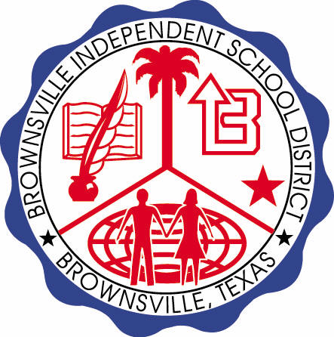

**READING WITH PURPOSE (CPQ) & THINK TURN TALK**

**SUBJECT: Reading-1st Grade- RESOURCE: HMH –Gus Takes the Train**

**Genre: Fantasy**

**How does the main character change from the beginning to the end of the story?**

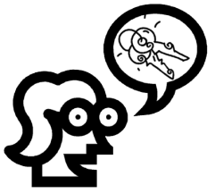

Making ConnectionsC:\Documents and Settings\ddycha\Local Settings\Temporary Internet Files\Content.IE5\1TTJYVJL\MCj03299300000[1].wmf

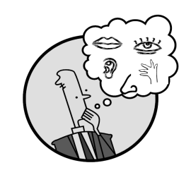Creating Mental Images

**Write your CPQ (comprehension purpose question) here.**

How do the illustrations help you know that *Gus Takes the Train* is fiction? P.147

Making Inferences & PredictionsC:\Documents and Settings\ddycha\Local Settings\Temporary Internet Files\Content.IE5\PICBQBTG\MCj02503920000[1].wmf

Vocabulary word:

conductor

**Think Turn Talk Question & page #**

Asking & Answering QuestionsC:\Documents and Settings\ddycha\Local Settings\Temporary Internet Files\Content.IE5\D3TFXU7L\MCj03841720000[1].wmf

As the story develops, how does the setting change? P.156

Determining Importance & Summarizing

Vocabulary word:

sip

**Think Turn Talk Question & page #**

Why do you think the author wrote this selection? P.156

Monitoring & ClarifyingC:\Documents and Settings\ddycha\Local Settings\Temporary Internet Files\Content.IE5\PICBQBTG\MCj04242520000[1].wmf

**Think Turn Talk Question & page #**