**Brownsville I.S.D.**





**READING WITH PURPOSE (CPQ) & THINK TURN TALK**

**SUBJECT: Reading-1st Grade-RESOURCE : HMH –Lucia’s Neighborhood**

**Genre: Informational Text**

**What was the author’s purpose in using photographs and captions throughout the selection?**  C:\Documents and Settings\ddycha\Local Settings\Temporary Internet Files\Content.IE5\D3TFXU7L\MCj03841720000[1].wmf

Making ConnectionsC:\Documents and Settings\ddycha\Local Settings\Temporary Internet Files\Content.IE5\1TTJYVJL\MCj03299300000[1].wmf

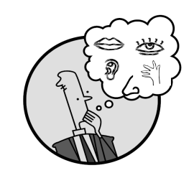Creating Mental Images

**Write your CPQ (comprehension purpose question) here.**

Why do you think photographs are included on this page? P.115

Making Inferences & PredictionsC:\Documents and Settings\ddycha\Local Settings\Temporary Internet Files\Content.IE5\PICBQBTG\MCj02503920000[1].wmf

Vocabulary word:

neighborhoodod

**Think Turn Talk Question & page #**

Asking & Answering QuestionsC:\Documents and Settings\ddycha\Local Settings\Temporary Internet Files\Content.IE5\D3TFXU7L\MCj03841720000[1].wmf

How do the captions help us understand the text? P.117

Determining Importance & Summarizing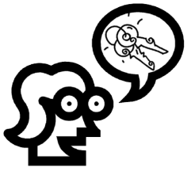

Vocabulary word:

biblioteca

**Think Turn Talk Question & page #**

Why do you think the author wrote this selection? P.122

Monitoring & ClarifyingC:\Documents and Settings\ddycha\Local Settings\Temporary Internet Files\Content.IE5\PICBQBTG\MCj04242520000[1].wmf

**Think Turn Talk Question & page #**