**Brownsville I.S.D.**





**READING WITH PURPOSE (CPQ) & THINK TURN TALK**

**SUBJECT: Reading-1st Grade- RESOURCE : HMH –Curious George at School**

**Genre: Fantasy**

**How do the events in the story help you summarize the selection?**

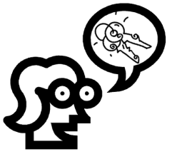

Making ConnectionsC:\Documents and Settings\ddycha\Local Settings\Temporary Internet Files\Content.IE5\1TTJYVJL\MCj03299300000[1].wmf

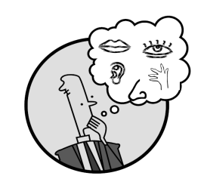Creating Mental Images

**Write your CPQ (comprehension purpose question) here.**

What clues make you think George is funny? P.81

Making Inferences & PredictionsC:\Documents and Settings\ddycha\Local Settings\Temporary Internet Files\Content.IE5\PICBQBTG\MCj02503920000[1].wmf

Vocabulary word:

mix

**Think Turn Talk Question & page #**

Asking & Answering QuestionsC:\Documents and Settings\ddycha\Local Settings\Temporary Internet Files\Content.IE5\D3TFXU7L\MCj03841720000[1].wmf

Can you elaborate on the reason why George is sad? P.87

Determining Importance & Summarizing

Vocabulary word:

mess

**Think Turn Talk Question & page #**

What would have happened if George had asked for help before making the mess? P.89

Monitoring & ClarifyingC:\Documents and Settings\ddycha\Local Settings\Temporary Internet Files\Content.IE5\PICBQBTG\MCj04242520000[1].wmf

**Think Turn Talk Question & page #**