**Brownsville I.S.D.**





**READING WITH PURPOSE (CPQ) & THINK TURN TALK**

**SUBJECT: Reading-1st Grade- RESOURCE: HMH –The Storm**

**Genre: Realistic Fiction**

Making ConnectionsC:\Documents and Settings\ddycha\Local Settings\Temporary Internet Files\Content.IE5\1TTJYVJL\MCj03299300000[1].wmf

**What kind of person is Pop? How do you know?**

C:\Documents and Settings\ddycha\Local Settings\Temporary Internet Files\Content.IE5\PICBQBTG\MCj02503920000[1].wmf

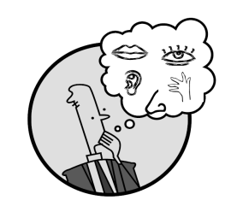Creating Mental Images

**Write your CPQ (comprehension purpose question) here.**

How do Tim and Rip feel about Pop? P.50

Making Inferences & PredictionsC:\Documents and Settings\ddycha\Local Settings\Temporary Internet Files\Content.IE5\PICBQBTG\MCj02503920000[1].wmf

Vocabulary word:

storm

**Think Turn Talk Question & page #**

Asking & Answering QuestionsC:\Documents and Settings\ddycha\Local Settings\Temporary Internet Files\Content.IE5\D3TFXU7L\MCj03841720000[1].wmf

How does the storm make Tim and Rip feel? What information does the author provide for you to think that? P.53

Determining Importance & Summarizing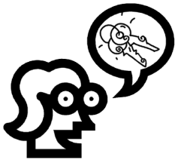

Vocabulary word:

hid

**Think Turn Talk Question & page #**

How did Pop help Tim and Rip overcome their fear? P.56

Monitoring & ClarifyingC:\Documents and Settings\ddycha\Local Settings\Temporary Internet Files\Content.IE5\PICBQBTG\MCj04242520000[1].wmf

**Think Turn Talk Question & page #**

