**Brownsville I.S.D.**





**READING WITH PURPOSE (CPQ) & THINK TURN TALK**

**SUBJECT: Reading-1st Grade- RESOURCE: HMH –A Butterfly Grows Genre: Narrative Nonfiction**

**Why is the sequence of events of the butterfly cycle important?**

Making ConnectionsC:\Documents and Settings\ddycha\Local Settings\Temporary Internet Files\Content.IE5\1TTJYVJL\MCj03299300000[1].wmf

**Write your CPQ (comprehension purpose question) here.**

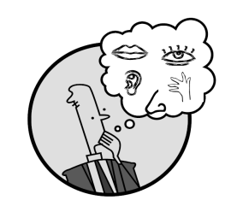Creating Mental Images

What other animals hatch? P.137

Making Inferences & PredictionsC:\Documents and Settings\ddycha\Local Settings\Temporary Internet Files\Content.IE5\PICBQBTG\MCj02503920000[1].wmf

**Think Turn Talk Question & page #**

Vocabulary words:

caterpillar

hatched

plips

plops

milkweed

snug

Shed

Can you compare the butterfly cycle to any other life cycle? P.136-150C:\Documents and Settings\ddycha\Local Settings\Temporary Internet Files\Content.IE5\PICBQBTG\MCj02503920000[1].wmf

Asking & Answering QuestionsC:\Documents and Settings\ddycha\Local Settings\Temporary Internet Files\Content.IE5\D3TFXU7L\MCj03841720000[1].wmf

**Think Turn Talk Question & page #**

Determining Importance & Summarizing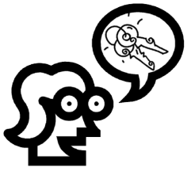

Identify the butterfly cycle with pictures and text from the story? P. 136-150

Monitoring & ClarifyingC:\Documents and Settings\ddycha\Local Settings\Temporary Internet Files\Content.IE5\PICBQBTG\MCj04242520000[1].wmf

**Think Turn Talk Question & page #**