**Brownsville I.S.D.**



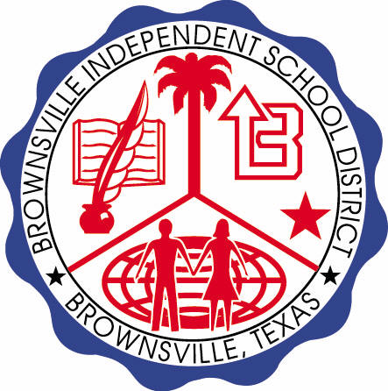

**READING WITH PURPOSE (CPQ) & THINK TURN TALK**

**SUBJECT: Reading-1st Grade- RESOURCE: HMH – Whistle for Willie Genre: Realistic Fiction**

**Can you predict if Willie will whistle? Elaborate.**



Making ConnectionsC:\Documents and Settings\ddycha\Local Settings\Temporary Internet Files\Content.IE5\1TTJYVJL\MCj03299300000[1].wmf

**Write your CPQ (comprehension purpose question) here.**

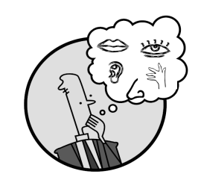Creating Mental Images

Can you elaborate on why Willie isn’t able to whistle? P.94-105

Making Inferences & PredictionsC:\Documents and Settings\ddycha\Local Settings\Temporary Internet Files\Content.IE5\PICBQBTG\MCj02503920000[1].wmf

**Think Turn Talk Question & page #**

Vocabulary words:

whistle

whirled

carton

Can you think of a time when you whirled and thought the world seemed to be going around and around? Explain. P. 96-97

Asking & Answering QuestionsC:\Documents and Settings\ddycha\Local Settings\Temporary Internet Files\Content.IE5\D3TFXU7L\MCj03841720000[1].wmf

**Think Turn Talk Question & page #**

Determining Importance & Summarizing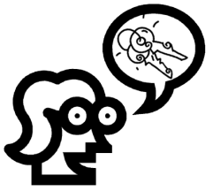

How would you describe the sequence of events in the story? P.94-112

Monitoring & ClarifyingC:\Documents and Settings\ddycha\Local Settings\Temporary Internet Files\Content.IE5\PICBQBTG\MCj04242520000[1].wmf

**Think Turn Talk Question & page #**