**Brownsville I.S.D.**



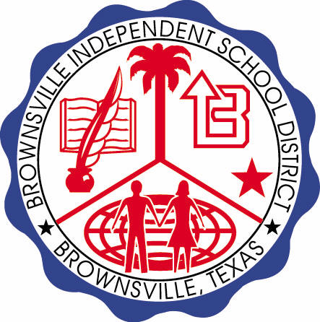

**READING WITH PURPOSE (CPQ) & THINK TURN TALK**

**SUBJECT: Reading-1st Grade- RESOURCE: HMH –Amazing Animals Genre: Informational Text**

**How do animal traits help them survive in their environment?**

Making ConnectionsC:\Documents and Settings\ddycha\Local Settings\Temporary Internet Files\Content.IE5\1TTJYVJL\MCj03299300000[1].wmf

**Write your CPQ (comprehension purpose question) here.**

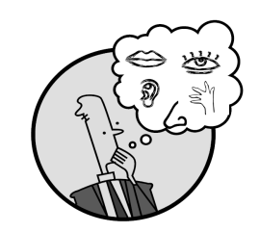Creating Mental Images

What are the similarities and differences between a turtle and a duck? P. 61, 68 

Making Inferences & PredictionsC:\Documents and Settings\ddycha\Local Settings\Temporary Internet Files\Content.IE5\PICBQBTG\MCj02503920000[1].wmf

**Think Turn Talk Question & page #**

Vocabulary words:

fur

camouflage

tube

tusks

trunks

hump

What text evidence supports the need for animals to adapt to their environment? P. 54-70

Asking & Answering QuestionsC:\Documents and Settings\ddycha\Local Settings\Temporary Internet Files\Content.IE5\D3TFXU7L\MCj03841720000[1].wmf

**Think Turn Talk Question & page #**

Determining Importance & Summarizing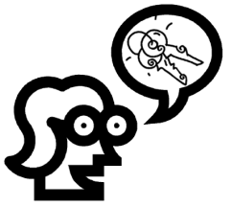

What information is most important in this story? P. 54-70

Monitoring & ClarifyingC:\Documents and Settings\ddycha\Local Settings\Temporary Internet Files\Content.IE5\PICBQBTG\MCj04242520000[1].wmf

**Think Turn Talk Question & page #**