**Brownsville I.S.D.**



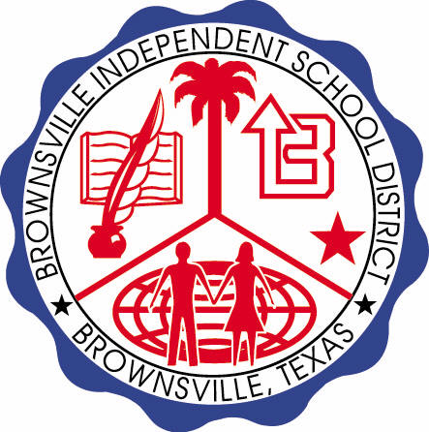

**READING WITH PURPOSE (CPQ) & THINK TURN TALK**

**SUBJECT: Reading-1st Grade- RESOURCE: HMH – Poppleton Genre: Fantasy**

**How does Poppleton’s problem get solved at the end of the story?**

Making ConnectionsC:\Documents and Settings\ddycha\Local Settings\Temporary Internet Files\Content.IE5\1TTJYVJL\MCj03299300000[1].wmf

**Write your CPQ (comprehension purpose question) here.**

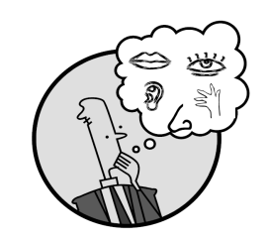Creating Mental Images

What is happening at the beginning of the story?Describe in your own words.P. 16-22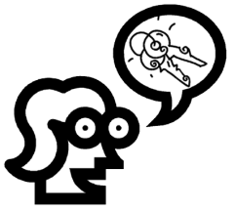

Making Inferences & PredictionsC:\Documents and Settings\ddycha\Local Settings\Temporary Internet Files\Content.IE5\PICBQBTG\MCj02503920000[1].wmf

**Think Turn Talk Question & page #**

Vocabulary words:

bark

tapped

stroked

wondered

Do the suggestions of Hudson and Newhouse help the tree? Explain why or why not. P.23-24



Asking & Answering QuestionsC:\Documents and Settings\ddycha\Local Settings\Temporary Internet Files\Content.IE5\D3TFXU7L\MCj03841720000[1].wmf

**Think Turn Talk Question & page #**

Determining Importance & Summarizing

Could the events in this story really happen in real life? Why or why not?



Monitoring & ClarifyingC:\Documents and Settings\ddycha\Local Settings\Temporary Internet Files\Content.IE5\PICBQBTG\MCj04242520000[1].wmf

**Think Turn Talk Question & page #**