**Brownsville I.S.D.**





**READING WITH PURPOSE (CPQ) & THINK TURN TALK**

**SUBJECT: Reading-1st Grade- RESOURCE: HMH – Little Rabbit’s Tale Genre: Folktale**

**How do Little Rabbit’s actions impact others?**

C:\Documents and Settings\ddycha\Local Settings\Temporary Internet Files\Content.IE5\PICBQBTG\MCj02503920000[1].wmf

Making ConnectionsC:\Documents and Settings\ddycha\Local Settings\Temporary Internet Files\Content.IE5\1TTJYVJL\MCj03299300000[1].wmf

**Write your CPQ (comprehension purpose question) here.**

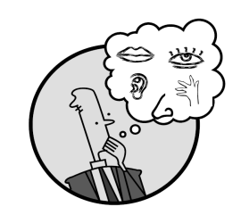Creating Mental Images

How did the apple falling on Little Rabbit’s head affect him? P.178

Making Inferences & PredictionsC:\Documents and Settings\ddycha\Local Settings\Temporary Internet Files\Content.IE5\PICBQBTG\MCj02503920000[1].wmf

**Think Turn Talk Question & page #**

What do you think will happen to each of Little Rabbit’s friends when they hear, “The sky is falling!”? P.180-187

Vocabulary words:

tale

twitch

stream

peeks

Asking & Answering QuestionsC:\Documents and Settings\ddycha\Local Settings\Temporary Internet Files\Content.IE5\D3TFXU7L\MCj03841720000[1].wmf

**Think Turn Talk Question & page #**

Determining Importance & Summarizing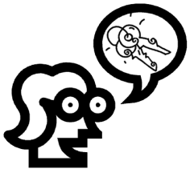

Can you name a situation where you were affected by others? Explain.

Monitoring & ClarifyingC:\Documents and Settings\ddycha\Local Settings\Temporary Internet Files\Content.IE5\PICBQBTG\MCj04242520000[1].wmf

**Think Turn Talk Question & page #**