**Brownsville I.S.D.**

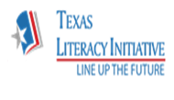

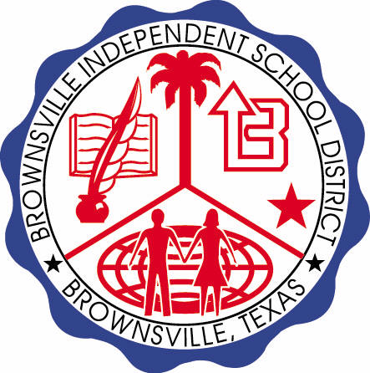

**READING WITH PURPOSE (CPQ) & THINK TURN TALK**

**SUBJECT: Reading-1st Grade- RESOURCE: HMH –What Is a Pal?**

**Genre: Informational Text**

Making ConnectionsC:\Documents and Settings\ddycha\Local Settings\Temporary Internet Files\Content.IE5\1TTJYVJL\MCj03299300000[1].wmf

**Can you explain how having pals affect your life?**

C:\Documents and Settings\ddycha\Local Settings\Temporary Internet Files\Content.IE5\1TTJYVJL\MCj03299300000[1].wmf

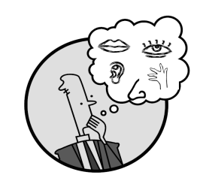Creating Mental Images

**Write your CPQ (comprehension purpose question) here.**

What are things a pal can do for you? P.19

Making Inferences & PredictionsC:\Documents and Settings\ddycha\Local Settings\Temporary Internet Files\Content.IE5\PICBQBTG\MCj02503920000[1].wmf

Vocabulary word:

pal

**Think Turn Talk Question & page #**

How can pets and parents be your pals too? P.21

Asking & Answering QuestionsC:\Documents and Settings\ddycha\Local Settings\Temporary Internet Files\Content.IE5\D3TFXU7L\MCj03841720000[1].wmf

Vocabulary word:

pet

**Think Turn Talk Question & page #**

Determining Importance & Summarizing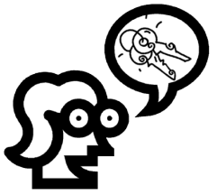

What activities can you do with your pals? P.24

Monitoring & ClarifyingC:\Documents and Settings\ddycha\Local Settings\Temporary Internet Files\Content.IE5\PICBQBTG\MCj04242520000[1].wmf

**Think Turn Talk Question & page #**