**Brownsville I.S.D.**



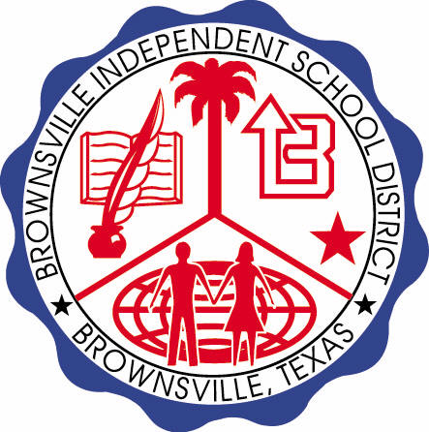

**READING WITH PURPOSE (CPQ) & THINK TURN TALK**

**SUBJECT: Reading-1st Grade- RESOURCE: HMH – Tomas Rivera**

**Genre: Biography**

**How did Tomas’s grandpa influence Tomas in becoming an author?**

Making ConnectionsC:\Documents and Settings\ddycha\Local Settings\Temporary Internet Files\Content.IE5\1TTJYVJL\MCj03299300000[1].wmf

**Write your CPQ (comprehension purpose question) here.**

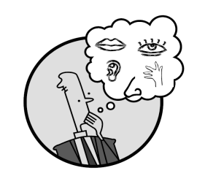Creating Mental Images

How did Tomas feel about picking crops? P. 143

Making Inferences & PredictionsC:\Documents and Settings\ddycha\Local Settings\Temporary Internet Files\Content.IE5\PICBQBTG\MCj02503920000[1].wmf

**Think Turn Talk Question & page #**

Which paragraph best describes how Tomas feels about his grandpa’s stories? P. 144-145

Vocabulary words:

crops

gasped

wink

Asking & Answering QuestionsC:\Documents and Settings\ddycha\Local Settings\Temporary Internet Files\Content.IE5\D3TFXU7L\MCj03841720000[1].wmf

**Think Turn Talk Question & page #**

Determining Importance & Summarizing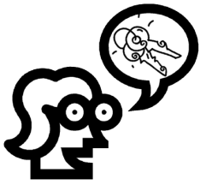

What conclusion can you draw about Tomas’s life as an author? P. 152-154

Monitoring & ClarifyingC:\Documents and Settings\ddycha\Local Settings\Temporary Internet Files\Content.IE5\PICBQBTG\MCj04242520000[1].wmf

**Think Turn Talk Question & page #**