**Brownsville I.S.D.**



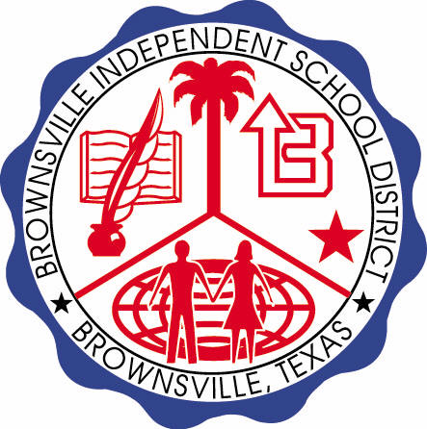

**READING WITH PURPOSE (CPQ) & THINK TURN TALK**

**SUBJECT: Reading-1st Grade- RESOURCE: HMH – Where Does Food Come**

**From? Genre: Informational Text**

**How would you summarize the selection, “Where Does Food Come From”, in your own words?**

Making ConnectionsC:\Documents and Settings\ddycha\Local Settings\Temporary Internet Files\Content.IE5\1TTJYVJL\MCj03299300000[1].wmf

**Write your CPQ (comprehension purpose question) here.**

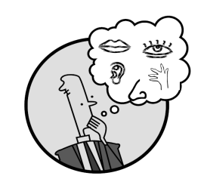Creating Mental Images

Have you read this information in another article? Where?

Making Inferences & PredictionsC:\Documents and Settings\ddycha\Local Settings\Temporary Internet Files\Content.IE5\PICBQBTG\MCj02503920000[1].wmf

**Think Turn Talk Question & page #**

What kind of foods mentioned in the story are products of grains? P.118

Vocabulary word:

cocoa

grain

vines

nectar

sap

Asking & Answering QuestionsC:\Documents and Settings\ddycha\Local Settings\Temporary Internet Files\Content.IE5\D3TFXU7L\MCj03841720000[1].wmf

**Think Turn Talk Question & page #**

Determining Importance & Summarizing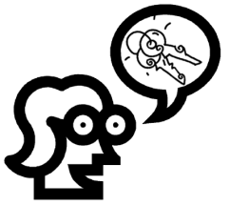

What kinds of food grow underground and what kinds grow on the ground? P. 104-111

Monitoring & ClarifyingC:\Documents and Settings\ddycha\Local Settings\Temporary Internet Files\Content.IE5\PICBQBTG\MCj04242520000[1].wmf

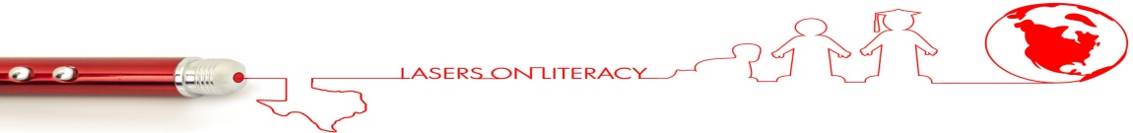**Think Turn Talk Question & page #**