**Brownsville I.S.D.**



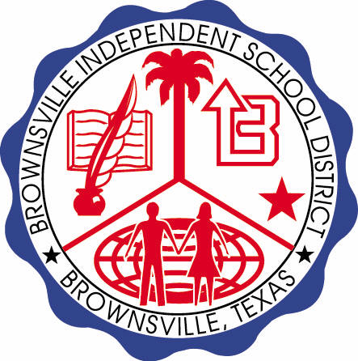

**READING WITH PURPOSE (CPQ) & THINK TURN TALK**

**SUBJECT: Reading-1st Grade- RESOURCE: HMH –The Big Trip**

**Genre: Fantasy**

**If you had a choice to travel like the characters in this selection, which choice of transportation would you choose? Why?**



Making ConnectionsC:\Documents and Settings\ddycha\Local Settings\Temporary Internet Files\Content.IE5\1TTJYVJL\MCj03299300000[1].wmf

**Write your CPQ (comprehension purpose question) here.**

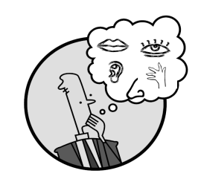Creating Mental Images

What text evidence tells you that this selection is fantasy? P. 58-76

Vocabulary word:

trip

stubborn

cart

engine

reef

Making Inferences & PredictionsC:\Documents and Settings\ddycha\Local Settings\Temporary Internet Files\Content.IE5\PICBQBTG\MCj02503920000[1].wmf

**Think Turn Talk Question & page #**

Compare and contrast traveling by horse and donkey cart. P.62-65

Asking & Answering QuestionsC:\Documents and Settings\ddycha\Local Settings\Temporary Internet Files\Content.IE5\D3TFXU7L\MCj03841720000[1].wmf

**Think Turn Talk Question & page #**

Determining Importance & Summarizing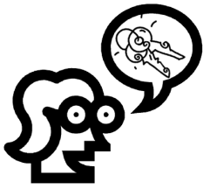

How do you know from the text that Goat wanted to go to the trip all along? P. 59-76



Monitoring & ClarifyingC:\Documents and Settings\ddycha\Local Settings\Temporary Internet Files\Content.IE5\PICBQBTG\MCj04242520000[1].wmf

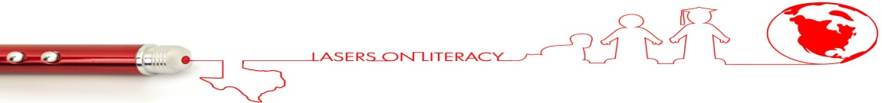**Think Turn Talk Question & page #**