**Brownsville I.S.D.**



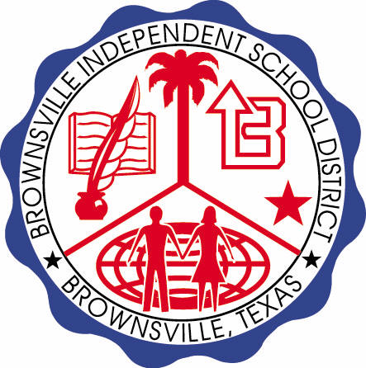

**READING WITH PURPOSE (CPQ) & THINK TURN TALK**

**SUBJECT: Reading-1st Grade- RESOURCE: HMH –Let’s Go to the Moon Genre: Informational Text**

**Do you think it is important to explore outer space? Give examples to validate your answer.**



Making ConnectionsC:\Documents and Settings\ddycha\Local Settings\Temporary Internet Files\Content.IE5\1TTJYVJL\MCj03299300000[1].wmf

**Write your CPQ (comprehension purpose question) here.**

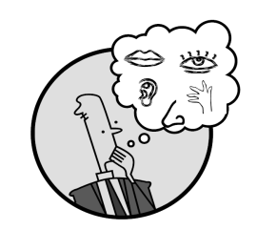Creating Mental Images

What attributes would you use to describe a crater? P. 19

Making Inferences &PredictionsC:\Documents and Settings\ddycha\Local Settings\Temporary Internet Files\Content.IE5\PICBQBTG\MCj02503920000[1].wmf

Vocabulary word:

blast

**Think Turn Talk Question & page #**

What is the purpose of a lunar rover on the moon? P. 26

Asking & Answering QuestionsC:\Documents and Settings\ddycha\Local Settings\Temporary Internet Files\Content.IE5\D3TFXU7L\MCj03841720000[1].wmf

**Think Turn Talk Question & page #**

Vocabulary word:

gravity

Determining Importance & Summarizing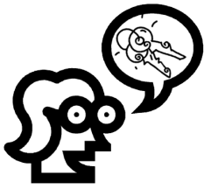

Why is it important for astronauts to be prepared for a lunar mission? P. 34



Monitoring & ClarifyingC:\Documents and Settings\ddycha\Local Settings\Temporary Internet Files\Content.IE5\PICBQBTG\MCj04242520000[1].wmf

**Think Turn Talk Question & page #**