**Brownsville I.S.D.**





**READING WITH PURPOSE (CPQ) & THINK TURN TALK**

**SUBJECT: Reading-1st Grade-RESOURCE: HMH –Animal Groups**

**Genre: Informational Text**

Making ConnectionsC:\Documents and Settings\ddycha\Local Settings\Temporary Internet Files\Content.IE5\1TTJYVJL\MCj03299300000[1].wmf

**What makes animals belong in a group together?**

C:\Documents and Settings\ddycha\Local Settings\Temporary Internet Files\Content.IE5\PICBQBTG\MCj04242520000[1].wmf

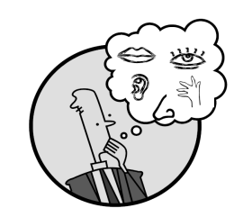Creating Mental Images

**Write your CPQ (comprehension purpose question) here.**

How do the pictures in *Animal Groups* help you figure out that the selection is an informational text? P.175

Making Inferences & PredictionsC:\Documents and Settings\ddycha\Local Settings\Temporary Internet Files\Content.IE5\PICBQBTG\MCj02503920000[1].wmf

Vocabulary word:

scales

**Think Turn Talk Question & page #**

Asking & Answering QuestionsC:\Documents and Settings\ddycha\Local Settings\Temporary Internet Files\Content.IE5\D3TFXU7L\MCj03841720000[1].wmf

How are amphibians and reptiles alike? How are they different? P.181

Determining Importance & Summarizing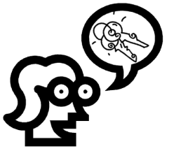

Vocabulary word:

slides

**Think Turn Talk Question & page #**

What makes mammal moms different from bird moms? P.187

Monitoring & ClarifyingC:\Documents and Settings\ddycha\Local Settings\Temporary Internet Files\Content.IE5\PICBQBTG\MCj04242520000[1].wmf

**Think Turn Talk Question & page #**

