**Brownsville I.S.D.**



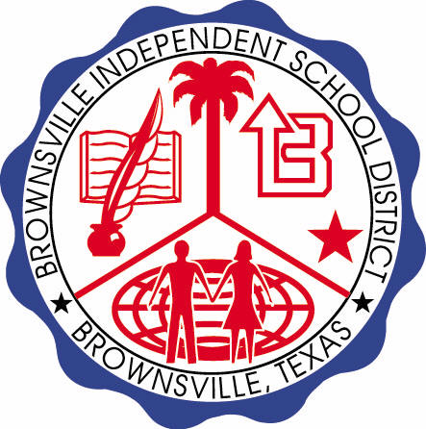

**READING WITH PURPOSE (CPQ) & THINK TURN TALK**

**SUBJECT: Reading-1st Grade-RESOURCE: HMH –The Big Race**

**Genre: Fantasy**

**What conclusions can you draw after reading the selection?**

C:\Documents and Settings\ddycha\Local Settings\Temporary Internet Files\Content.IE5\PICBQBTG\MCj02503920000[1].wmf

Making ConnectionsC:\Documents and Settings\ddycha\Local Settings\Temporary Internet Files\Content.IE5\1TTJYVJL\MCj03299300000[1].wmf

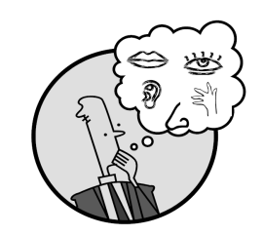Creating Mental Images

**Write your CPQ (comprehension purpose question) here.**

Who do you predict will win the race? What makes you think that? P.135

Making Inferences & PredictionsC:\Documents and Settings\ddycha\Local Settings\Temporary Internet Files\Content.IE5\PICBQBTG\MCj02503920000[1].wmf

Vocabulary word:

crowd

**Think Turn Talk Question & page #**

Asking & Answering QuestionsC:\Documents and Settings\ddycha\Local Settings\Temporary Internet Files\Content.IE5\D3TFXU7L\MCj03841720000[1].wmf

How do the animals in the crowd feel about the race? How do you know? P.139

Determining Importance & Summarizing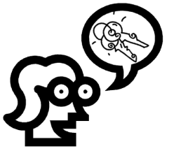

Vocabulary word:

chases

**Think Turn Talk Question & page #**

After Red Lizard wins the race, why is everyone else happy? What does this teach us about Red Lizard? P.148

Monitoring & ClarifyingC:\Documents and Settings\ddycha\Local Settings\Temporary Internet Files\Content.IE5\PICBQBTG\MCj04242520000[1].wmf

**Think Turn Talk Question & page #**