**Brownsville I.S.D.**



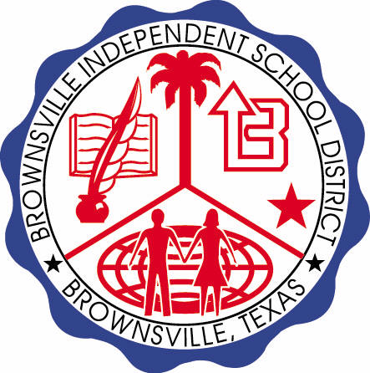

**READING WITH PURPOSE (CPQ) & THINK TURN TALK**

**SUBJECT: Reading-1st Grade-RESOURCE: HMH –Seasons**

**Genre: Informational Text**

**What changes do the different seasons cause?**

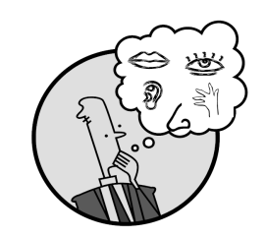C:\Documents and Settings\ddycha\Local Settings\Temporary Internet Files\Content.IE5\1TTJYVJL\MCj03299300000[1].wmf

Making ConnectionsC:\Documents and Settings\ddycha\Local Settings\Temporary Internet Files\Content.IE5\1TTJYVJL\MCj03299300000[1].wmf

Creating Mental Images

**Write your CPQ (comprehension purpose question) here.**

Why do you think little chicks sing to their parents? P.94

Making Inferences & PredictionsC:\Documents and Settings\ddycha\Local Settings\Temporary Internet Files\Content.IE5\PICBQBTG\MCj02503920000[1].wmf

Vocabulary word:

blow

**Think Turn Talk Question & page #**

Asking & Answering QuestionsC:\Documents and Settings\ddycha\Local Settings\Temporary Internet Files\Content.IE5\D3TFXU7L\MCj03841720000[1].wmf

How does the author compare the plants and the boy? P.98

Determining Importance & Summarizing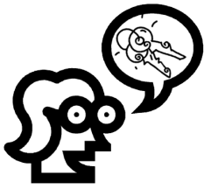

Vocabulary word:

gust

**Think Turn Talk Question & page #**

How are the seasons the same? How are they different? P.108

Monitoring & ClarifyingC:\Documents and Settings\ddycha\Local Settings\Temporary Internet Files\Content.IE5\PICBQBTG\MCj04242520000[1].wmf

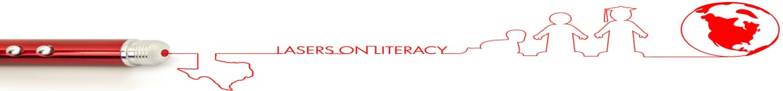**Think Turn Talk Question & page #**