**Brownsville I.S.D.**



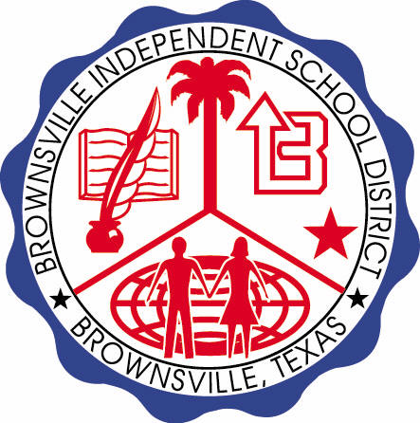

**READING WITH PURPOSE (CPQ) & THINK TURN TALK**

**SUBJECT: Reading-1st Grade-RESOURCE: HMH –How Leopard Got His Spots**

**Genre: Folktale**

**How does Fred change from the beginning to the end of the story? What events cause this change?**

C:\Documents and Settings\ddycha\Local Settings\Temporary Internet Files\Content.IE5\D3TFXU7L\MCj03841720000[1].wmf

Making ConnectionsC:\Documents and Settings\ddycha\Local Settings\Temporary Internet Files\Content.IE5\1TTJYVJL\MCj03299300000[1].wmf

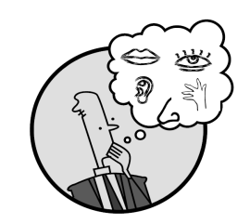Creating Mental Images

**Write your CPQ (comprehension purpose question) here.**

What conclusions can you draw about Fred and Hal’s friendship? P.56

Making Inferences & PredictionsC:\Documents and Settings\ddycha\Local Settings\Temporary Internet Files\Content.IE5\PICBQBTG\MCj02503920000[1].wmf

Vocabulary word:

trick

**Think Turn Talk Question & page #**

Asking & Answering QuestionsC:\Documents and Settings\ddycha\Local Settings\Temporary Internet Files\Content.IE5\D3TFXU7L\MCj03841720000[1].wmf

How are Len Leopard and Hal Hyena different? P.59

Determining Importance & Summarizing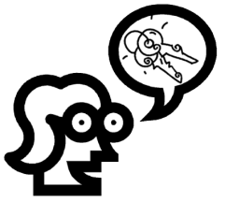

Vocabulary word:

frisky

**Think Turn Talk Question & page #**

Can you explain how Len Leopard affected Fred’s behavior throughout the story? P.68

Monitoring & ClarifyingC:\Documents and Settings\ddycha\Local Settings\Temporary Internet Files\Content.IE5\PICBQBTG\MCj04242520000[1].wmf

**Think Turn Talk Question & page #**