**Brownsville I.S.D.**



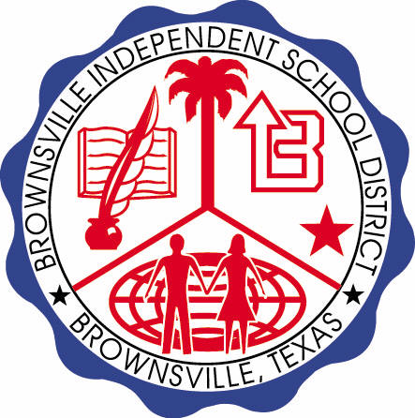

**READING WITH PURPOSE (CPQ) & THINK TURN TALK**

**SUBJECT: ReadingRESOURCE or BOOK: HMH –Sea Animals**

**Genre: Informational Text**

**What was the author’s purpose in writing this selection? What facts would you select to support your answer?** C:\Documents and Settings\ddycha\Local Settings\Temporary Internet Files\Content.IE5\PICBQBTG\MCj02503920000[1].wmf

Making ConnectionsC:\Documents and Settings\ddycha\Local Settings\Temporary Internet Files\Content.IE5\1TTJYVJL\MCj03299300000[1].wmf

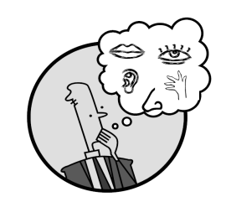Creating Mental Images

**Write your CPQ (comprehension purpose question) here.**

How would you compare and contrast the sea slug and the crab? P.23

Making Inferences & PredictionsC:\Documents and Settings\ddycha\Local Settings\Temporary Internet Files\Content.IE5\PICBQBTG\MCj02503920000[1].wmf

Vocabulary word:

flippers

**Think Turn Talk Question & page #**

Asking & Answering QuestionsC:\Documents and Settings\ddycha\Local Settings\Temporary Internet Files\Content.IE5\D3TFXU7L\MCj03841720000[1].wmf

What do you think would happen if the penguins and sea lions would switch habitats? P.25

Determining Importance & Summarizing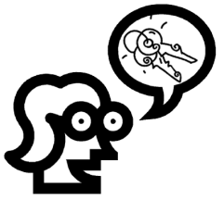

Vocabulary word:

hunt

**Think Turn Talk Question & page #**

What conclusions can you draw after reading *Sea Animals*? P.30

Monitoring & ClarifyingC:\Documents and Settings\ddycha\Local Settings\Temporary Internet Files\Content.IE5\PICBQBTG\MCj04242520000[1].wmf

**Think Turn Talk Question & page #**