**Brownsville I.S.D.**



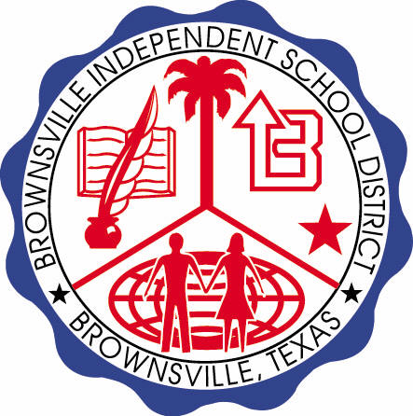

**READING WITH PURPOSE (CPQ) & THINK TURN TALK**

**SUBJECT: Reading-1st Grade-RESOURCE: HMH –A Cupcake Party**

**Genre: Fantasy**

**How would you describe Fritz? What clues in the story support your answer?**

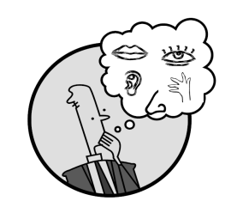

Making ConnectionsC:\Documents and Settings\ddycha\Local Settings\Temporary Internet Files\Content.IE5\1TTJYVJL\MCj03299300000[1].wmf

Creating Mental Images

**Write your CPQ (comprehension purpose question) here.**

How do the illustrations help you know that *A Cupcake Party* is fiction? P.159

Making Inferences &PredictionsC:\Documents and Settings\ddycha\Local Settings\Temporary Internet Files\Content.IE5\PICBQBTG\MCj02503920000[1].wmf

Vocabulary word:

grand

**Think Turn Talk Question & page #**

Asking & Answering QuestionsC:\Documents and Settings\ddycha\Local Settings\Temporary Internet Files\Content.IE5\D3TFXU7L\MCj03841720000[1].wmf

How would you summarize what we have read so far? P.165

Determining Importance & Summarizing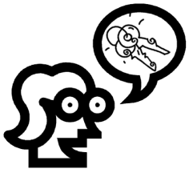

Vocabulary word:

stump

**Think Turn Talk Question & page #**

How do Fritz’s friends feel at the end of the story? How do you know? P.172

Monitoring & ClarifyingC:\Documents and Settings\ddycha\Local Settings\Temporary Internet Files\Content.IE5\PICBQBTG\MCj04242520000[1].wmf

**Think Turn Talk Question & page #**